**Guide Lines to run the application on server**

Requirement : Python

Steps: Download the files in your local machine and place them in following Location:

Inside the Folder where Python is installed 🡪 Floder named Scripts 🡪   
You must have created your project, go Inside if not Create One 🡪   
Inside Script folder you can Create as Many Apps as you want in your Project (Foe me project name I gave is : myproject) 🡪 Go inside Scripts Folder 🡪   
Go inside IndigoHD Folder (This is the App that you Will create) 🡪  
Inside this App (For me the app is : “IndigoHD”) Copy all the files inside the src Folder   
  
* C:\Python34\Scripts\myproject\Scripts \IndigoHD **( for my machine)**

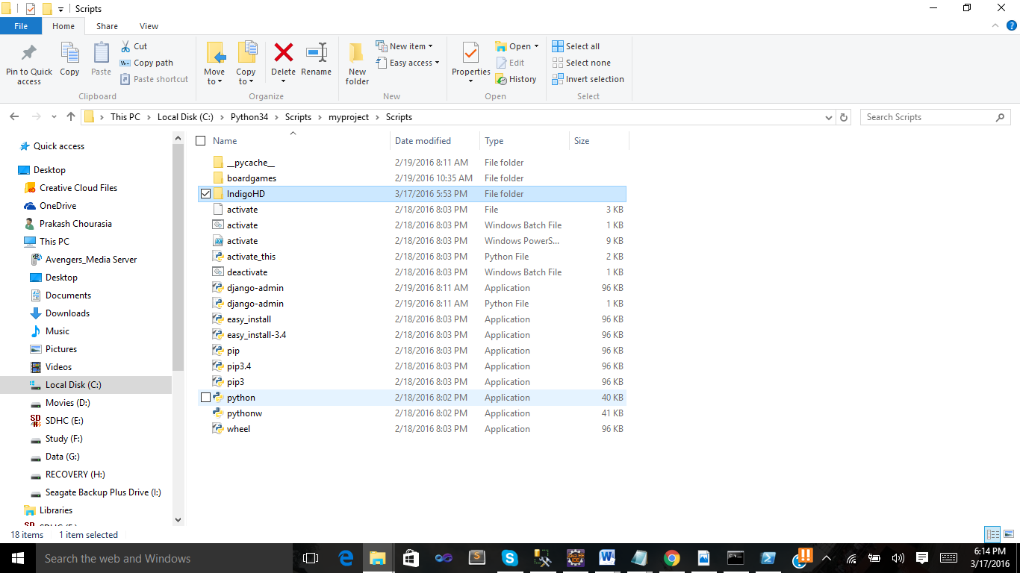

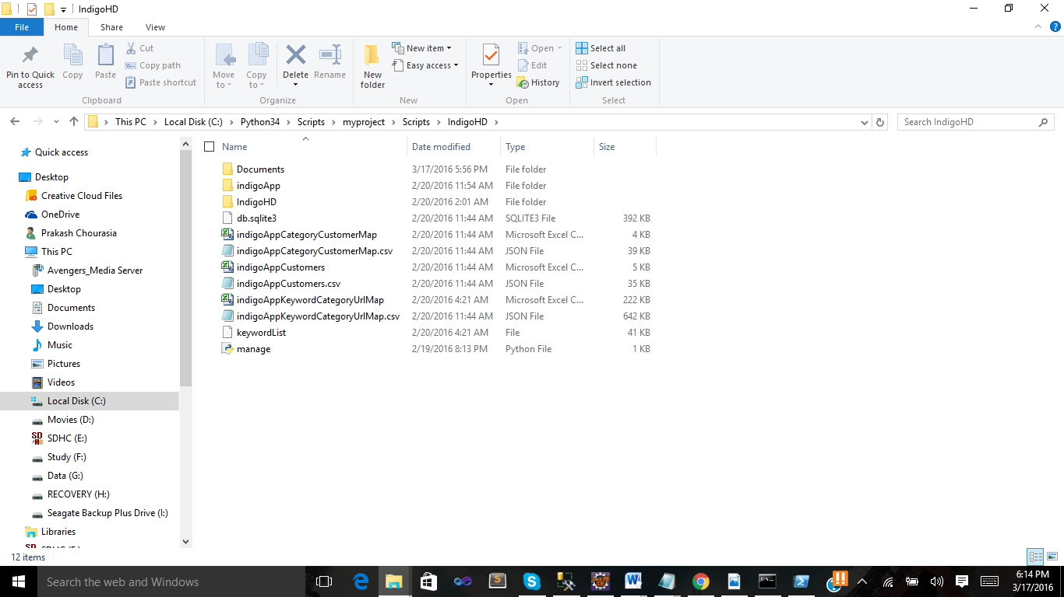

**Now run the Window PowerShell or Cmd Prompt**

Go to the following location : * C:\Python34\Scripts\myproject\Scripts

You can check see the Power Shell Script “activate” file in Explorer

Execute the activate file :

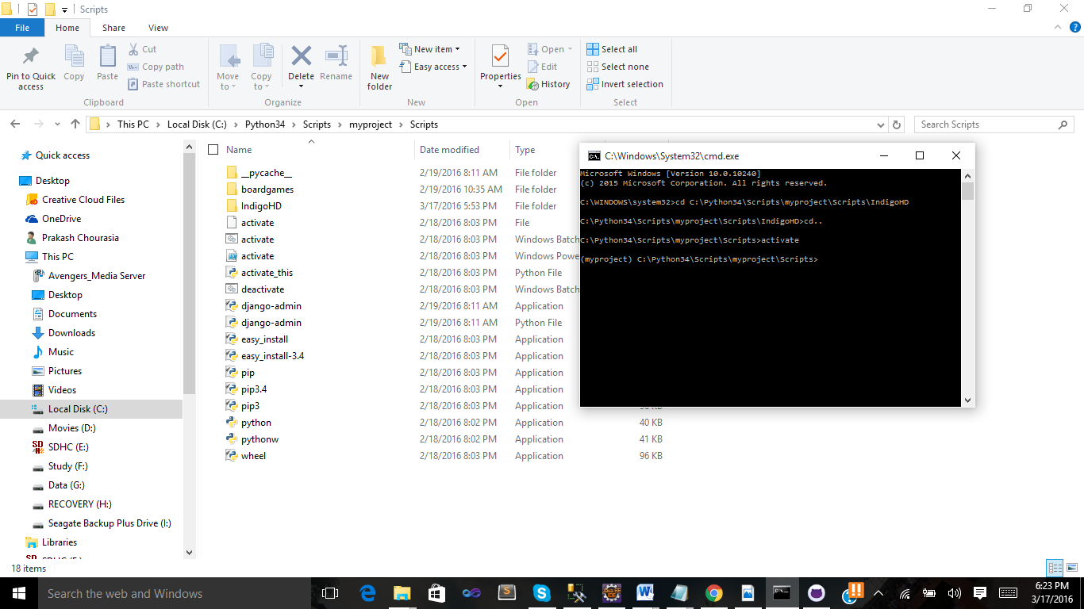

Now go Inside the Application (Here “IndigoHD”) , You can see manage.py file here  
If Not Please Check Above Steps.

Your Current Location is : C:\Python34\Scripts\myproject\Scripts\IndigoHD\

python manage.py runserver

Execute the Above Command

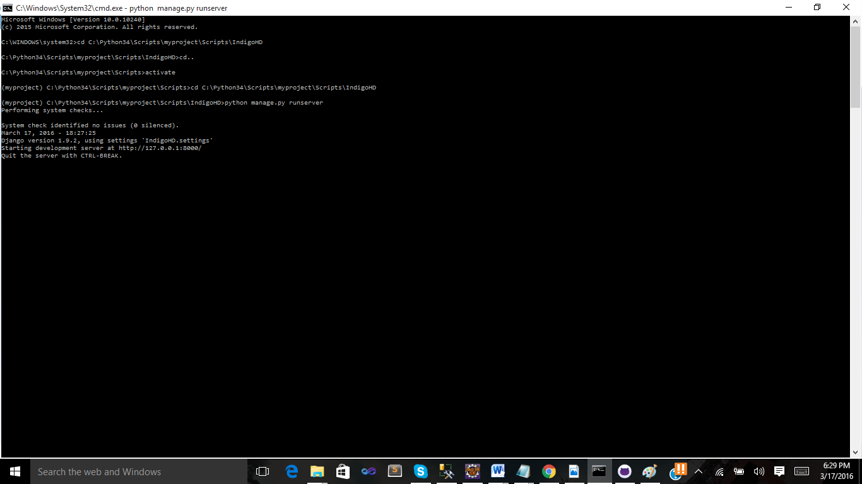

You will get Address for Deployed server : <http://127.0.0.1:8000/> open it in browser.

Thanks